ISO 27018 Compliance for Log360
Strengthen data protection and meet ISO 27018 compliance with Log360.
Region: International | Type: Data Privacy, Industry Standard | Category: Compliance | Pricing: Free

Overview
The ISO 27018 compliance extension in Log360 helps organizations meet ISO/IEC 27018:2019, an international code of practice for cloud PII processors establishing privacy-specific controls for protecting personally identifiable information in public cloud environments by providing centralized log management, real-time privacy threat detection, and cloud access auditing. The platform supports ISO 27018 requirements for PII access control, privacy audit logging, breach detection, third-party access management, data retention, cloud infrastructure security, and consent monitoring.
For PII Access Control and Authentication, Log360 monitors Windows and Active Directory logon events, failed authentication attempts, Entra ID user logon, risky sign-in alerts, and MFA activity to detect unauthorized access to PII-holding systems. To address Privacy Audit Logging and Accountability, the platform captures system event logs, process tracking, GPO auditing, Oracle and SQL Server audit records to provide comprehensive traceability of all actions taken on PII-containing systems. The extension also supports Data Breach Detection and Incident Response by providing capabilities that integrates FireEye, Trend Micro, McAfee, and Windows Threat Detection reports to identify security incidents and cloud storage security events that may constitute a PII breach requiring notification.

Key Features
- Third-Party and Cloud Service Access Management: Log360 monitors cloud storage integration, team and member management, AWS IAM activity, Entra application management, and user activity to audit all third-party access to cloud environments containing PII.
- PII Data Retention and Storage Security: Log360 monitors file changes, cloud storage file activity, AWS S3 file operations, and Exchange mailbox import/export events to track PII lifecycle from storage through authorized deletion.
- Cloud Infrastructure Security Monitoring: Log360 monitors AWS VPC activity, EC2 events, network security groups, WAF reports, AWS Config, and failed/unauthorized activity to secure the cloud infrastructure hosting PII.
- Consent and PII Use Oversight: Log360 audits SharePoint and OneDrive file access, Exchange mailbox activity, Salesforce content and report activity.


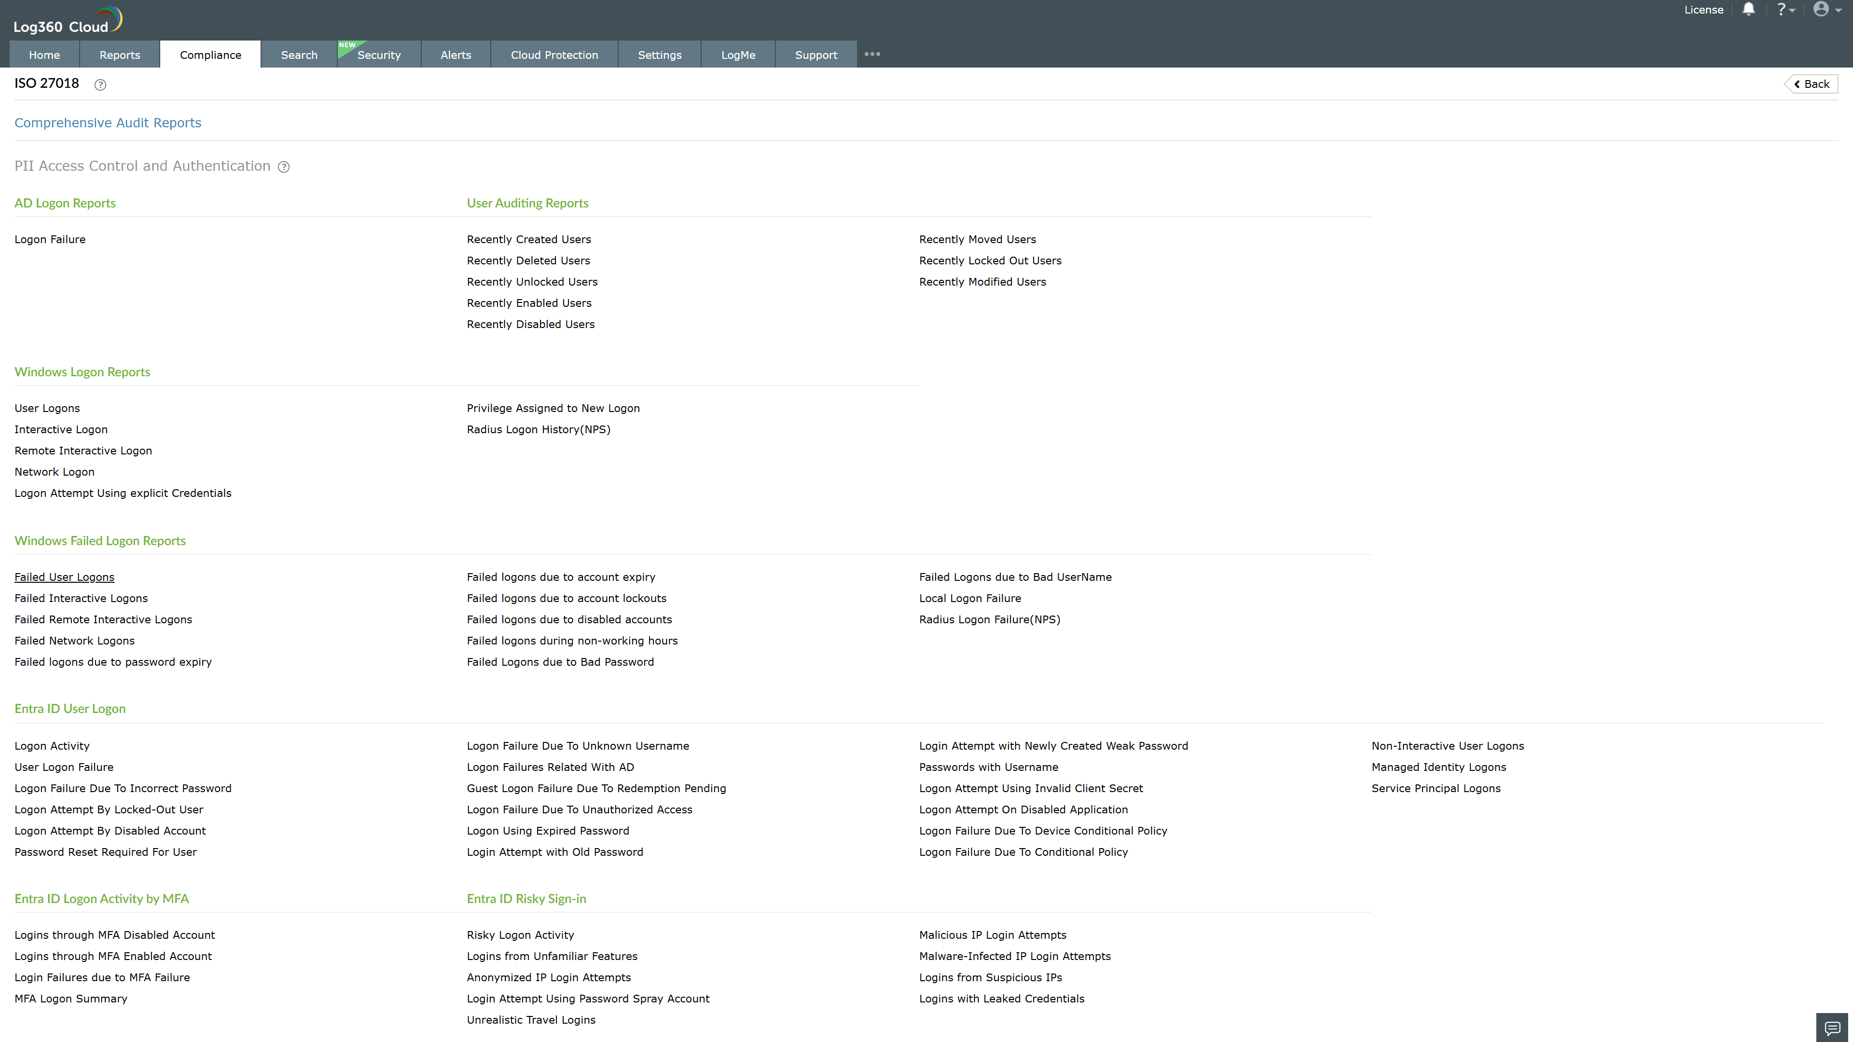
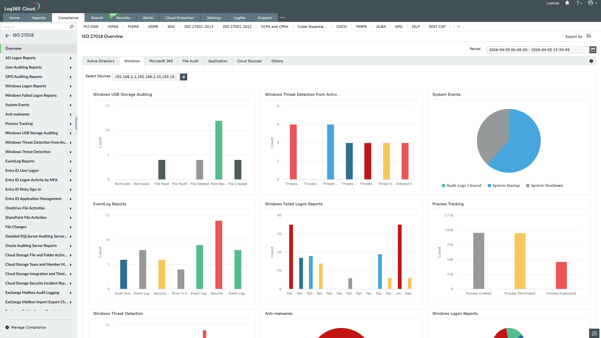
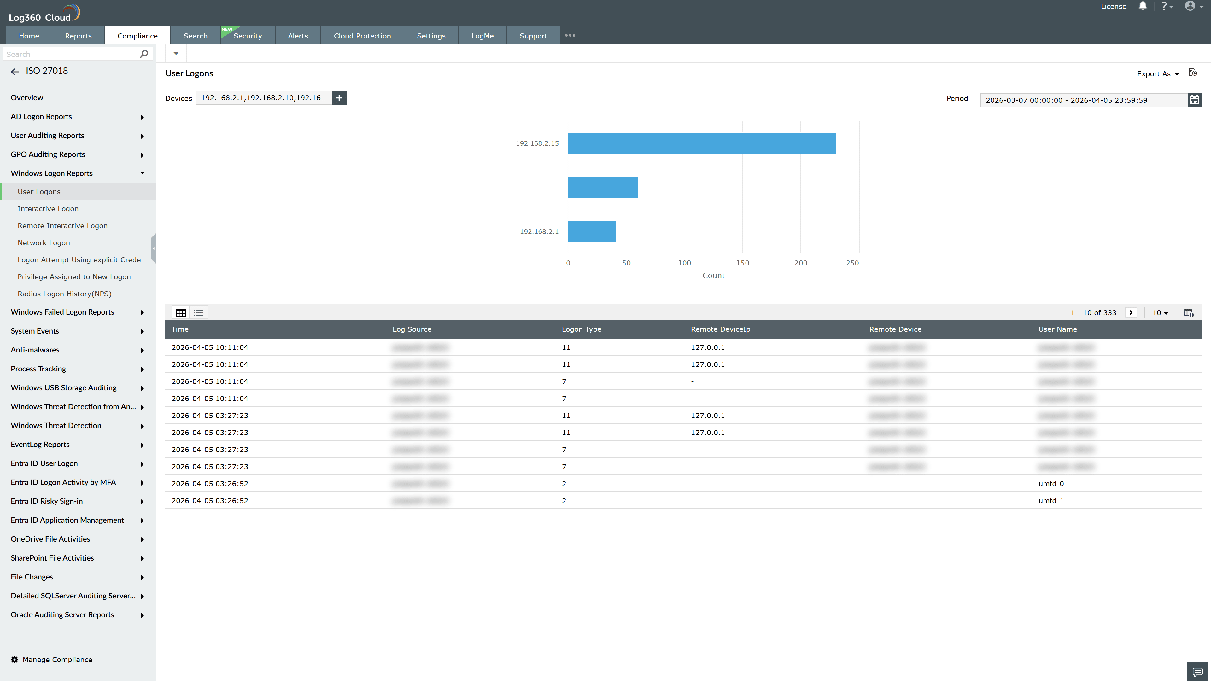
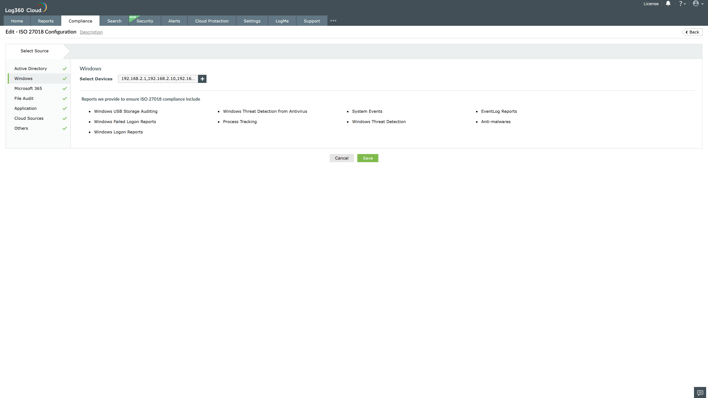
Valid Submission : Yes
Supported Editions : Free, Basic, Standard, Professional, MSSP
Help Document : https://www.manageengine.com/log-management/help/integrations/compliance-extensions.html
Help Video : Not provided
Tags : Log360, Compliance, Privacy monitoring, Data privacy, Regulatory compliance
Supported DCs : US, IN, JP, CA, AU, UK and EU
Privacy Policy:
Terms of Service:
Release Notes:
Predefined reports for the ISO 27018.

